In this document, I will give you explain of how make the network design of the assignment using the application GNS3 version 1.3.13. How first step, I downloaded the GNS3 both the ISO router Cisco 7200. Next, we import the ISO image into the GNS3.

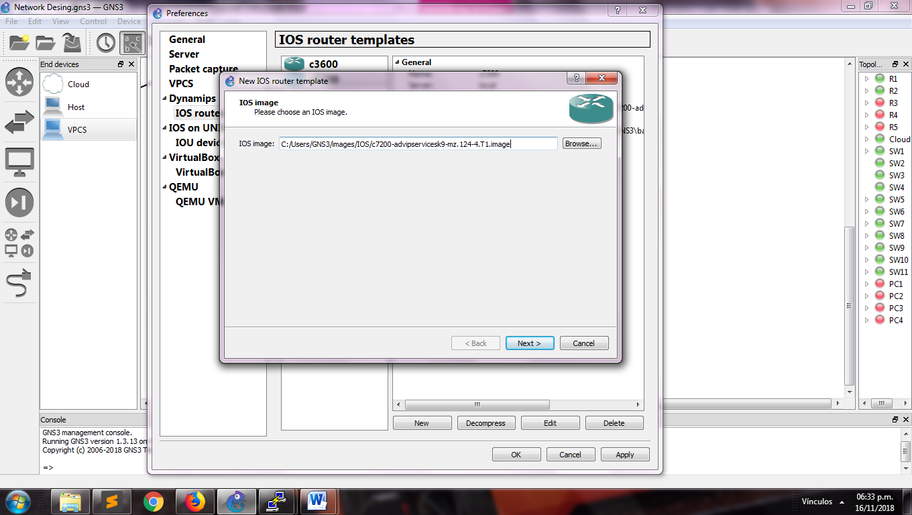

Inside our section “Routers”, we can find the router downloaded for be used. In this moment we can drag the components inside of our workspace.

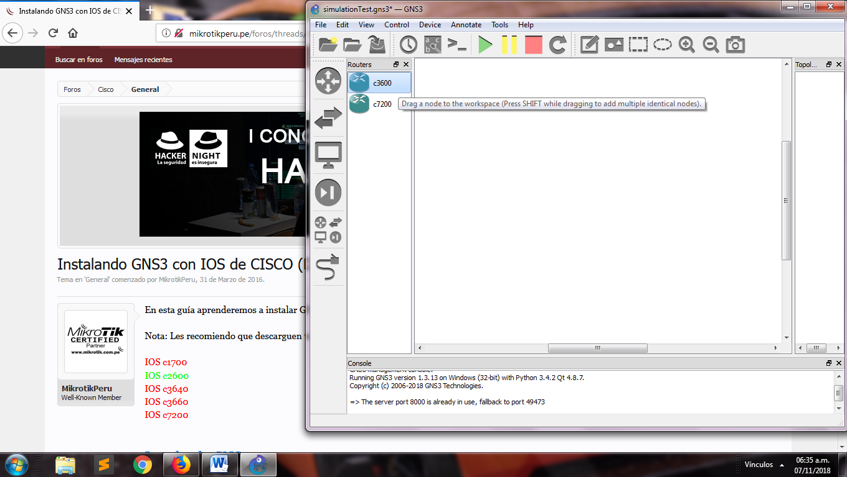

We can design our topology using all the components that GNS3 has, in this components we will find routers of CISCO, switches, hosts, VPCS, cloud for the connection to internet, hubs and wire for join the components.

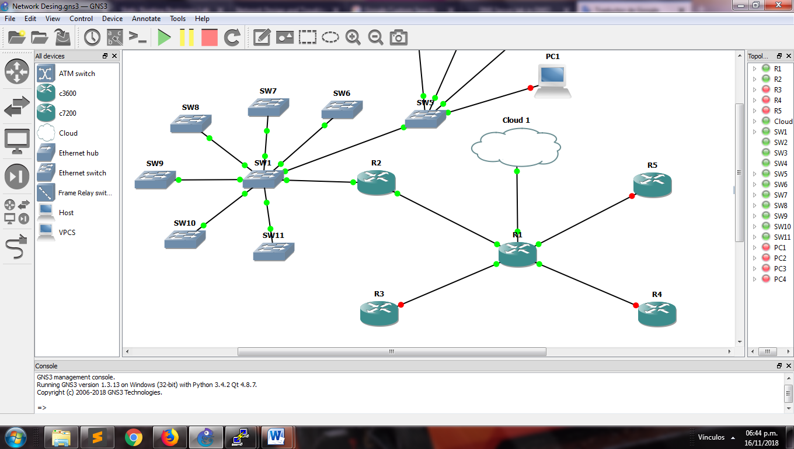

We will use two ips for our network; the ip address public is 130.140.150.160/26 with this we can connect to internet and our ip address private 192.168.168/24 which this stablish inside the company. It has four departments, each other with different number of host.

Due to, we will apply subnetting to the ip address private for we will obtain four different networks for each department. This distribution will be showed in the table below.

|  |  |  |  |  |  |  |  |  |
| --- | --- | --- | --- | --- | --- | --- | --- | --- |
| Nº | Requested host | Found Host | Network address | Mask | Decimal mask | First usable IP | Last usable IP | Broadcast  address |
| Finance | 67 Computers  1 Printer  1 server | 126 | 192.168.168.0 | /25 | 255.255.255.128 | 192.168.168.1 | 192.168.168.126 | 192.168.168.127 |
| IT | 37 Computers  1 Printer  1 Server | 62 | 192.168.168.128 | /26 | 255.255.255.192 | 192.168.168.129 | 192.168.168.190 | 192.168.168.191 |
| HR | 17 Computers  1 Printer  1 Server | 30 | 192.168.168.192 | /27 | 255.255.255.224 | 192.168.168.193 | 192.168.168.222 | 192.168.168.223 |
| Marketing | 9 Computers  1 Printer  1 Server | 14 | 192.168.168.224 | /28 | 255.255.255.240 | 192.168.168.225 | 192.168.168.238 | 192.168.168.239 |

Each network will be configured with a VLAN, listed of the next way:

|  |  |
| --- | --- |
| Department | VLAN number |
| Finance | 100 |
| Information Technology | 101 |
| Human Resources | 102 |
| Marketing | 103 |

In all the routers be to executed the follow lines inside its console. This will be available after to start the router.

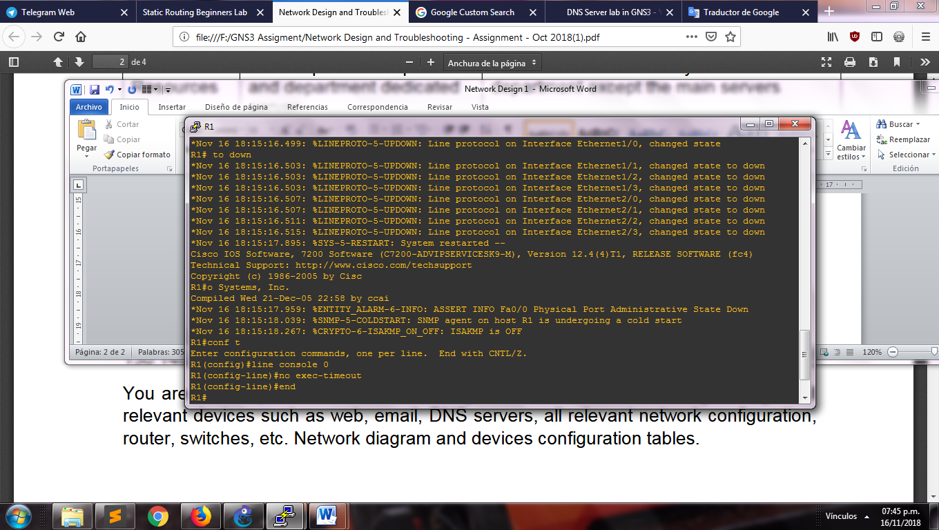

This lines disable the timeout for that the router don’t disconnect after some seconds of inactivity

We configure the slots in each router what it will permit us have the interface for the connections between the components. In our case, we will use a slot with eight interfaces in each router. This will show in the picture below:

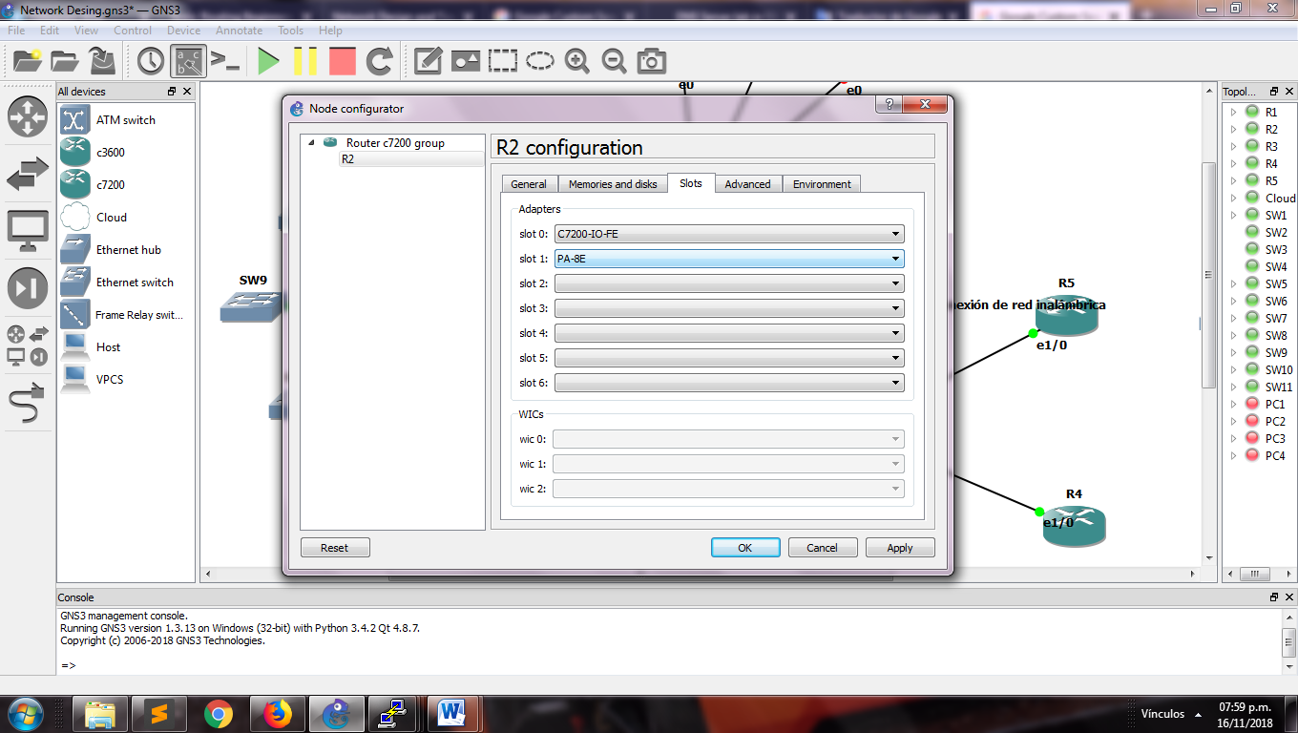

Next step will be to configure a network that connects the main router with the department router. We use the ip address showed below in the table:

|  |  |  |  |  |
| --- | --- | --- | --- | --- |
| Network address | Router | Router address | Interface main router (R1) | Interface address |
| 172.16.0.0/30 | R2 | 172.16.0.2 | Ethernet 1/0 | 172.16.0.1 |
| 172.16.1.0/30 | R3 | 172.16.1.2 | Ethernet 1/1 | 172.16.1.1 |
| 172.16.2.0/30 | R4 | 172.16.2.2 | Ethernet 1/2 | 172.16.2.1 |
| 172.16.3.0/30 | R5 | 172.16.3.2 | Ethernet 1/3 | 172.16.3.1 |

The commands are the follows:

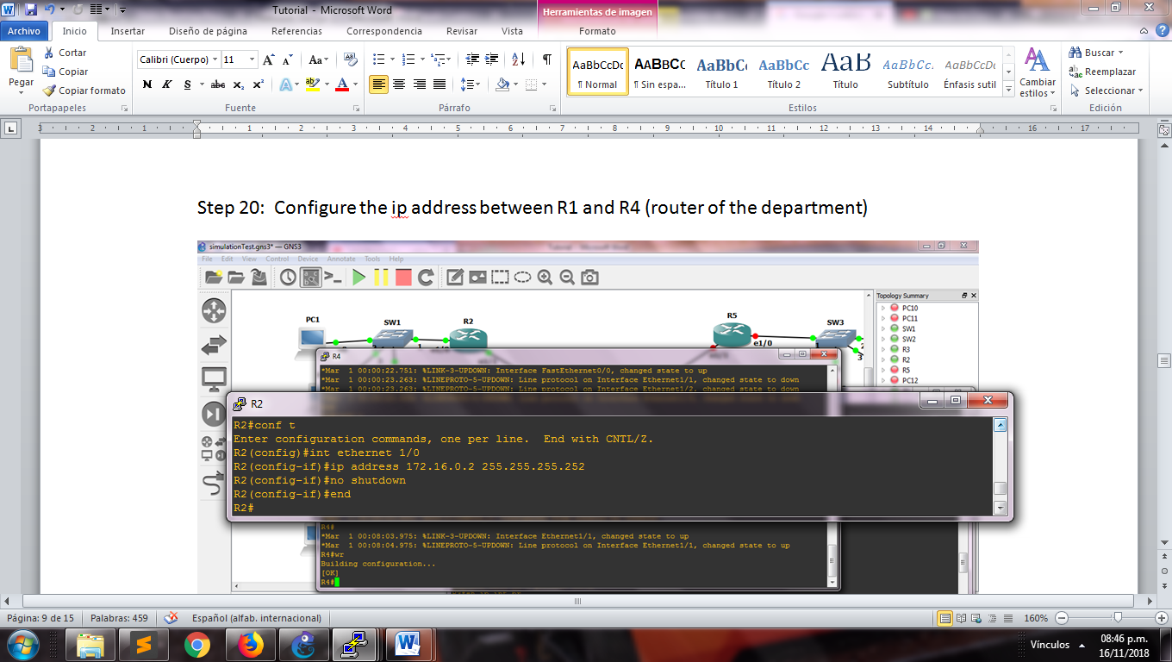

In the same way, we configure the main route in each interface connected to the routers and the interface for the external connection. The next image show each interface with its configuration

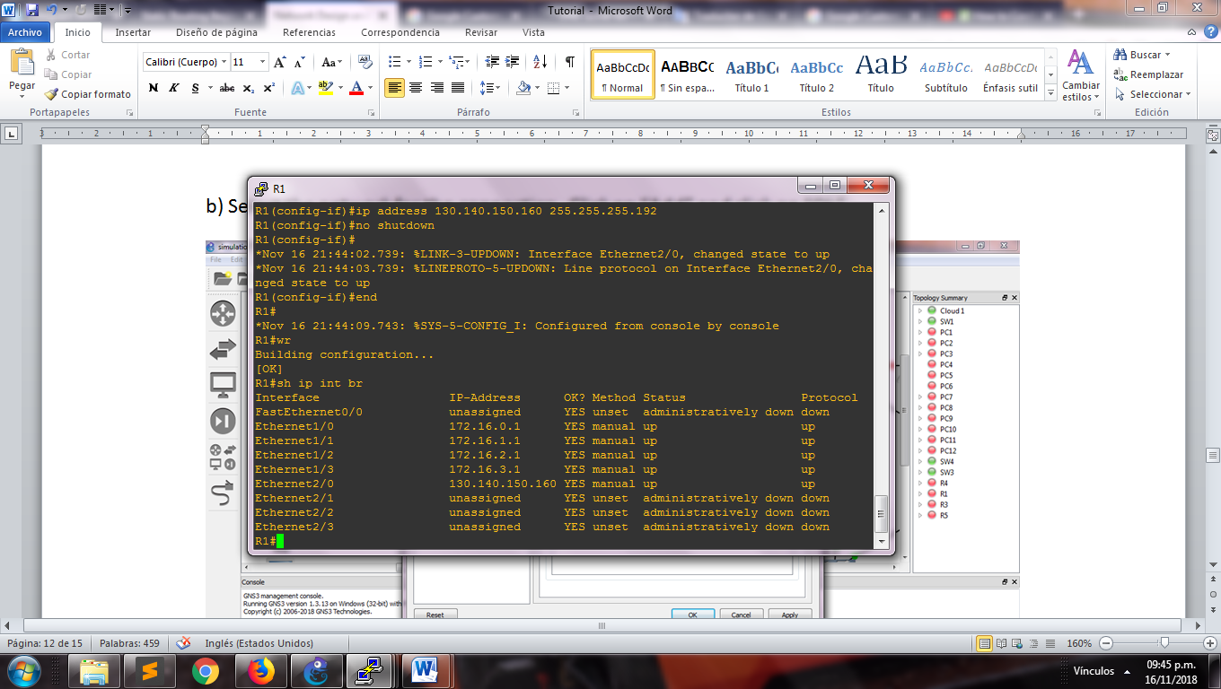

We can try the connection using the ping command with the direction of the router

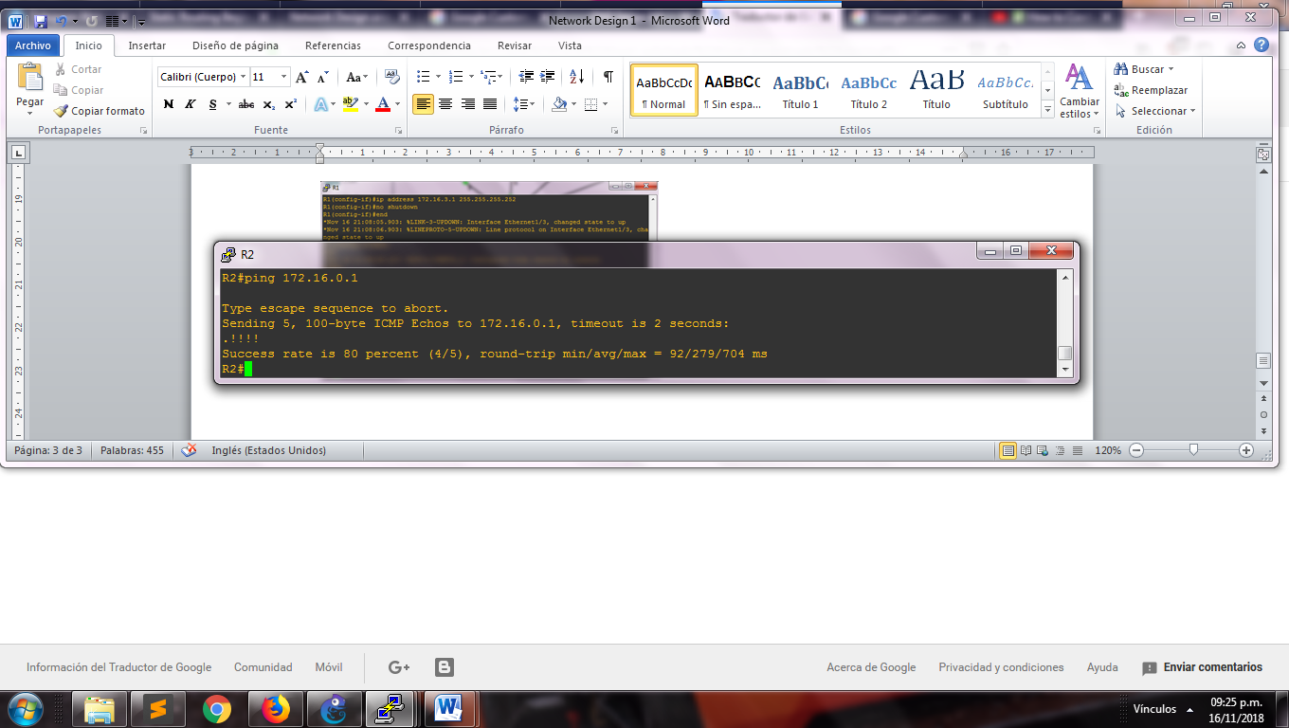

If it shows a high percentage of send, then the routers have a good communication

Now configure the switches with the name of the VLANs that it will be used into of each department

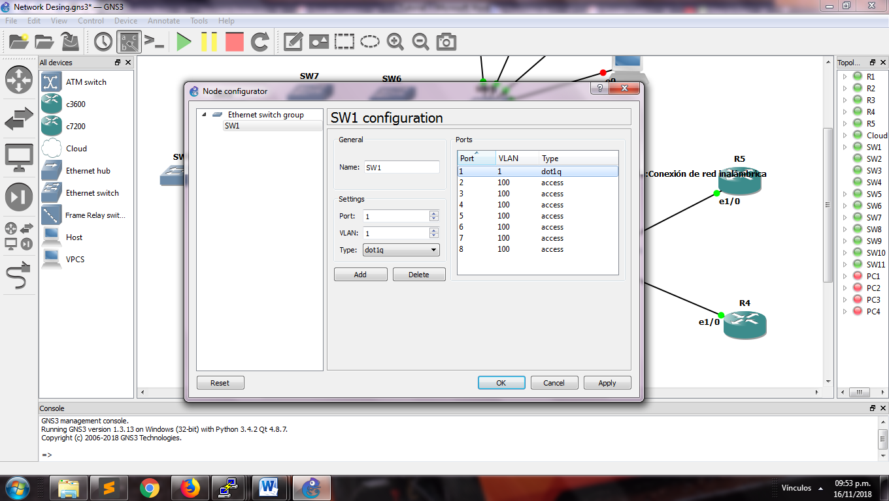

We configure in each interface of the main router the VLAN corresponding with the ip address of the subnetting

